Press release

Luminous sign for BMW Gregoir by Zumtobel
BMW's slogan “Sheer Driving Pleasure” is a promise that is delivered upon not only by every car they provide. This pleasure is also reflected in their car dealerships displaying a perfect balance between technology and aesthetic appeal. The focus of the design concept developed for the new BMW Gregoir car dealership at the Flemish municipality of Puurs was placed on perfect presentation of the premium cars, in order to convey the independent character and typical features of every individual BMW. In close collaboration with the architects and the electrical design engineer, an innovative lighting concept was created by the Austrian luminaire manufacturer Zumtobel.
Dornbirn, June 2015 – Early in 2014, the Belgian car dealer Hervé Gregoir acquired the BMW Gregoir car dealership at the Flemish municipality of Puurs where new and used cars of the premium brand BMW are sold. Serious changes to the adjacent motorway made a structural redesign of the car dealership necessary, as it no longer managed to attract the required attention from the newly elevated approach road. In addition, the existing building did no longer comply with BMW's design guidelines. Hervé Gregoir decided to raise a new building and commissioned the Belgian architects' studio of Lécharny & Bertrand to draw up a design. Except for the workshop, the entire complex had to be redesigned. Taking the BMW Group's strict design specifications also into account, the architects based in Wilrijk developed a contemporary architectural concept for a two-storey car dealership providing a perfect stage for the premium cars that is visible from afar. The solution is quite striking, as car dealerships in the region are usually one-storey buildings. The building, which was completed in only six months, comprises a two-storey showroom for new cars, a separate area for the presentation of used cars, an area for the delivery of new cars, offices and an entrance area opening up towards a lobby.
In collaboration with Lécharny & Bertrand and the electrical design engineer Jan Muyshondt, Zumtobel developed a custom lighting concept which enhances the clear lines and the powerfully modelled surfaces of the cars, thus creating an exciting interplay of light and shadows. For this purpose, Zumtobel used the modular INTRO lighting system which combines a variety of luminaire types based on cutting-edge LED technology. The LED accent spotlights used in Puurs can be rotated through 360° and swivelled in and out, thus enabling staging and pinpoint lighting in the car dealership. Furthermore, system output, colour temperature and light distribution of the spotlights can be combined individually, granting BMW Gregoir maximum flexibility. Another advantage is the convenient installation of the modular lighting system. In the event of repurposing specific areas, for instance, lighting inserts can also be de-installed at any time, and re-installed at a later date, without the use of any tools. In order to be able to combine both spotlights and diffuse light lines in one single lighting channel, Zumtobel made use of the flexible lighting system even before it was launched on the market.
In the context of a project headed by Hans Lambrechts, the luminaire manufacturer developed an individual custom solution for BMW Gregoir which combines two innovative LED luminaire systems, INTRO and SLOTLIGHT: along a length of 135 metres, the installation frame recessed into the ceiling accommodates 200 INTRO accent spots and some 60 custom-made SLOTLIGHT II ceiling-mounted LED luminaires to specifically suit the frame. The diffuse light provided by the light lines ensures a clear profile of the cars' reflective surfaces, whereas targeted spots produce a brilliant light, making details visible and suggesting vehicle movement.
Outside the entrance, Zumtobel installed SLOTLIGHT II LED individual luminaires with IP54 rating ensuring maximum protection from spray water and dust. Inside the entrance area, as well as in the offices and the lobby, 175 recessed LED downlights of the PANOS infinity and PANOS evolution ranges were installed, with additional DIAMO downlights mounted above the reception desk in the lobby. In the section reserved for used cars, some 80 luminaires of the TECTON continuous-row lighting system have been installed along a length of over 200 m and supplemented by LED spotlights of the VIVO range.
For the car delivery section, Zumtobel came up with another highlight: an offset rectangular lighting frame that is 11 m x 5 m in size. This integrated delivery section is defined by right-angled SLOTLIGHT II L connectors supported by high-precision PANOS infinity downlights. In order to provide the right ambience for handing over new cars, Zumtobel programmed a brief light & music show controlled by the LITECOM lighting management system. However, that is not the only special task fulfilled by this intuitive, app-based lighting control system. The system also allows individual control of all luminaires including those of the ONLITE RESCLITE emergency lighting system, which can even be dimmed individually, if required. LITECOM encompasses the entire physical structure of the building and maps all the relevant technical facilities appropriately. Rooms or parts of rooms can be amalgamated to form floor levels or other subdivisions in order to structure all the luminaires, sensors and controls of a building, including their mutual interactions, in a flexible manner.
Shortly after the opening of his car dealership, Hervé Gregoir delivers a positive summary: “For our site in Puurs, Zumtobel developed a lighting design concept that complies with all our requirements. And what's more: the concept is fit for the future and can be modified and extended at any time. For us this means plenty of additional security in terms of investment and up-to-dateness of design. We were able to communicate with all those involved – the architects, the electrical design engineer and Zumtobel – in a highly open and constructive manner at all times. We could not have made a better choice.” Two new projects by BMW Gregoir are proof of this belief: at present, Zumtobel is about to complete the lighting system for the workshop in Puurs, and a redesign of a lighting design concept for another car dealership is already being prepared.
Facts & figures on the Zumtobel products used
INTRO | Modular LED lighting system that can be perfectly customised for retail spaces; high flexibility; two alternative options each in terms of size, installation and lighting insert; front rings available in 5 different colours; high degree of architectural variability
SLOTLIGHT II LED | Individual luminaire with extruded aluminium section; PMMA diffuser made of opal acrylic glass to ensure uniform light distribution; halogen-free wiring; dimmable; electronic ballast featuring DALI control
PANOS infinity/evolution LED | LED downlight range; dimmable; colour temperature: 3000 K or 4000 K; high colour rendering index of Ra > 90; luminaire efficiency of > 100 lm/W; symmetrical beam pattern
DIAMO | Minimalist LED downlight; integral lighting solutions including wallwashers and 3-phase spotlights; colour temperature: 2700 K, 3000 K and 4000 K; colour rendering index: Ra 80 or 90; dimmable
TECTON | Continuous-row luminaire made of roll-formed sheet steel; 1- or 2-lamp version; halogen-free wiring; pre-fitted transparent lampholder shells; dimmable; electronic ballast featuring DALI control
VIVO LED | LED spotlight for accent lighting; swivelling spotlight; excellent colour rendering, choice of perfect light colour and glare control; luminous flux: up to 4210 lm; colour temperature: 3000 K or 4200 K; IR- and UV-free light
ONLITE RESCLITE LED | LED emergency luminaire for escape routes; low installed load of 5 W; high protection rating: IP 65 or IP 40; optional central or battery-operated power supply
LITECOM | App-based, open lighting management system; interconnection of controllers, touch panels and software; intuitive control via Web; straightforward and open installation technology; freely configurable functions thanks to plug-ins

Captions:
(Photo Credits: Zumtobel)

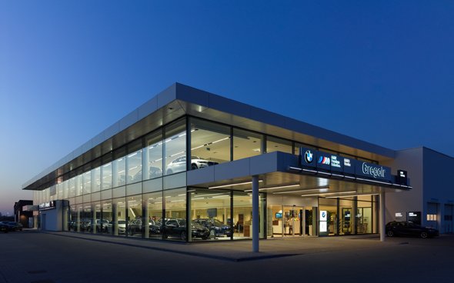
Fig. 1: The new building of BMW Gregoir at Puurs, Belgium, encompasses two storeys and is now visible from afar.

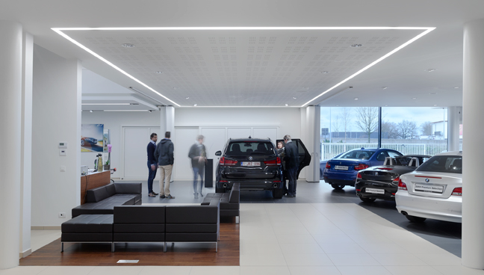
Fig. 2: The lighting system of the BMW car dealership had to comply with strict design specifications. Here you see the area where new cars are handed over, with a lighting frame featuring SLOTLIGHT II L connectors.

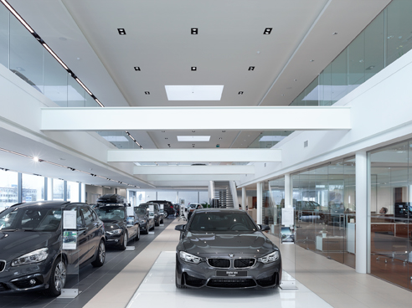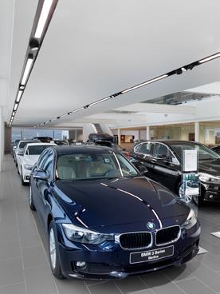
Fig. 3 and 4: In order to illuminate the showroom, Zumtobel developed a custom solution based on the modular INTRO LED lighting system.

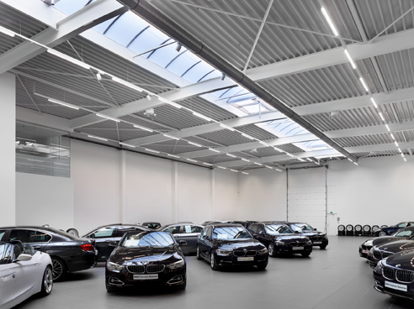
Fig. 5: In the sales space reserved for used cars, Zumtobel relied on minimalist lighting based on daylight.

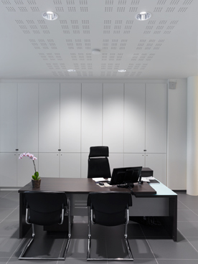
Fig. 6: In the sales offices, Zumtobel created a bright and pleasant lighting ambience.

Press contact:
Zumtobel Lighting GmbH
Sophie Moser
Head of Brand Communications
Schweizer Strasse 30
6850 Dornbirn
Austria

Tel: +43 5572 390 26527
Mobil: +43 664 80892 3074
press@zumtobel.com

www.zumtobel.com

Responsible sales office:
ZG Lighting Benelux
Rijksweg 47 - Industriezone Puurs Nr. 442
2870 Puurs
Belgium

Tel: +32 3 860 93 93
Fax: +32 3 886 25 00
info@zumtobel.be
info@zumtobel.lu

www.zumtobel.be
www.zumtobel.nl
www.zumtobel.lu

Sales contact:
Zumtobel Lighting Ltd.  Chiltern Park  Chiltern Hill, Chalfont St Peter  Buckinghamshire SL9 9FG  United Kingdom  Tel: +44 1753 482 650  Fax: +44 1753 480 350  uksales@zumtobel.com  www.zumtobel.co.uk | Zumtobel Lighting Inc.  3300 Route 9  Highland , NY 12528  United States  Tel: +1 845 691 6262  Fax: +1 845 691 6289  zli.us@zumtobelgroup.com  www.zumtobel.us

For further contact details in further sales regions please visit: http://www.zumtobel.com/com-en/contact.html

About Zumtobel
Zumtobel, a leading international supplier of integral lighting solutions, enables people to experience the interplay of light and architecture. As a leader in innovation, Zumtobel provides a comprehensive range of high-quality luminaires and lighting management systems for professional interior lighting in the areas of offices, education, presentation & retail, hotel & wellness, health, art & culture as well as industry. Zumtobel is a brand of Zumtobel Group AG with its head office in Dornbirn, Vorarlberg (Austria).
Zumtobel. The Light.

