Press release

A master of skilful presentation
Poland's first “tunableWhite” lighting solution at the Warsaw National Museum featuring ARCOS
The Warsaw National Museum is the largest and most important museum in Poland. Its most recent addition, the ARCOS LED spotlight, is a true master when it comes to presenting a wide variety of exhibits to optimum effect. In terms of energy and conservational aspects, ARCOS has achieved iconic status in lighting history. Due to its sophisticated lighting technology, it allows visitors to enjoy art in its most authentic form.
Dornbirn/Warsaw, June 2015 – The clients clearly specified what they wanted: perfect presentation of artworks and compliance with maximum conservational demands, combined with a dramatic reduction of the carbon footprint. The National Museum has now been fitted with an LED-only lighting solution. In Poland, the collection is the largest of its kind in the sphere of art, and the very first featuring tunableWhite technology, which ensures that visitors can fully enjoy the artworks on display.
The concept submitted by Zumtobel managed to win a public invitation to tender. The experience and know-how of the Austrian lighting specialist were decisive for the operators of the National Museum. In the sphere of art and culture, Zumtobel develops lighting solutions based on comprehensive studies investigating, among other things, the effects of light on sensitive artworks.
The right light for any exhibit
The ARCOS LED spotlight is a product resulting from this research. Due to its compact size, the high-performance LED module is ideal for accent lighting. Instead of 1100 halogen spotlights with an installed load of 100 W each, today 970 ARCOS spotlights featuring an installed load of 20 W each and 120 spotlights with 25 W each set the lighting stage for some 780,000 paintings and sculptures. One of the most decisive criteria concerned colour rendering, which was supposed to exceed RA 90. ARCOS mastered this requirement with a colour rendering index of RA 94 at a constant luminous flux level, independent of the colour temperature, and considerably lower energy consumption than conventional solutions.
However, in order to ensure a perfectly authentic experience of art, the spotlight has plenty more to offer: due to built-in tunableWhite technology, the light colour can be adjusted to the material, colour and character of each individual artwork. Gold, for instance, shines especially brightly when illuminated by warm white light colours, whereas materials like silver, steel or concrete are given a more favourable appearance by cool white light. With artworks from ancient to modern times on display, the demands in terms of lighting could not be more varied at the National Museum. Thanks to tunableWhite, the colour temperature of each spotlight can be adjusted, either manually at the luminaire unit or via the lighting management system. Moreover, the nearly UV- and IR-free light emitted by LEDs is gentle on the exhibits.
Flexible and with aesthetic appeal
The ARCOS spotlight itself cannot fail to impress thanks to its minimalist and uncluttered design. It was, however, especially important to the operators of the National Museum that the spotlight was also highly flexible and simple to handle in every-day use. Often it is the finest nuances in presentation that decide upon the effect created by an exhibit. Due to its large variety of accessories, ARCOS provides optimum prerequisites for finding a target-oriented solution to any lighting task in just a few simple steps. The built-in front ring painted in black not only serves as a holding ring for attachments, but above all also ensures glare-free lighting. In addition, every spotlight can be rotated through 360° and pivoted through 90°.
The lighting solution of the entire building, based on LEDs in combination with the BUTLER XT lighting management system including presence detectors, has reduced energy consumption at the National Museum already by 40 percent. Three out of five galleries have already been converted to the trend-setting lighting system; the other two will follow this year.

Captions:
(Photo credits: Zumtobel)
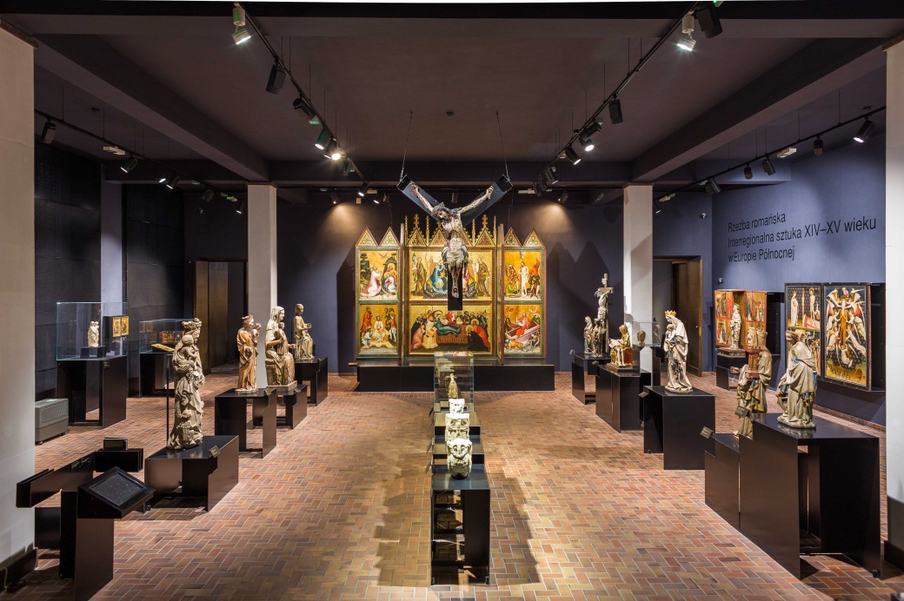
Fig. 1: The Warsaw National Museum is the largest and most important museum in Poland. The recently integrated ARCOS LED spotlights allow visitors to enjoy art in its most authentic form.
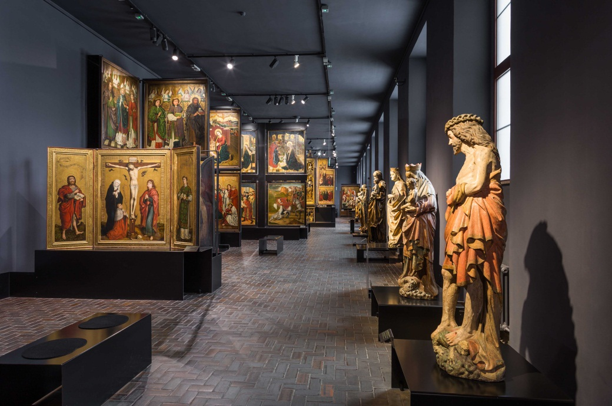
Fig. 2: The lighting solution was developed based on comprehensive studies investigating, among other things, the effects of light on sensitive artworks.
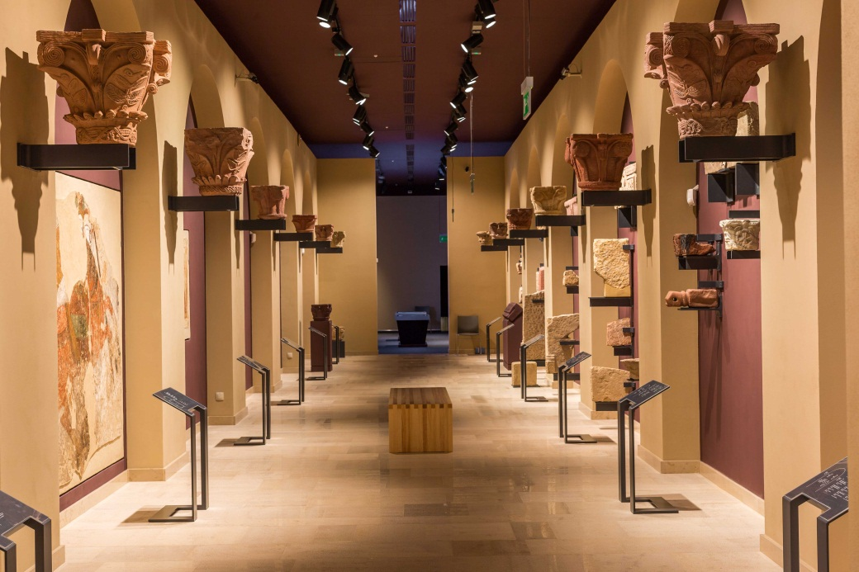
Fig. 3: The built-in tunableWhite technology offers a perfectly authentic experience of art, since the light colour can be adjusted to the material, colour and character of each individual artwork.
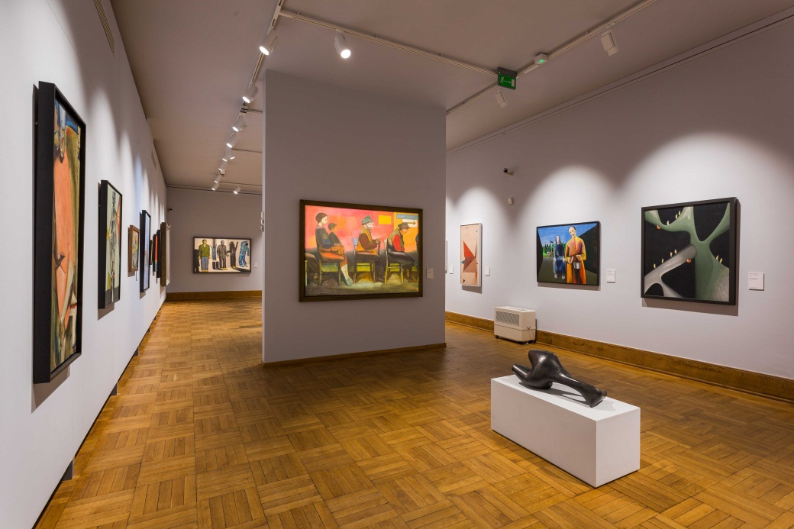
Fig. 4: ARCOS LED spotlights accomplish a perfect presentation of artworks and compliance with maximum conservational demands, combined with a dramatic reduction of the carbon footprint.

Press contact:
Zumtobel Lighting GmbH
Sophie Moser
Head of Brand Communications
Schweizer Strasse 30
A-6850 Dornbirn

Tel +43-5572-390-26527
Mobil +43-664-80892-3074
E-Mail press@zumtobel.com
www.zumtobel.com

Sales contact:
Zumtobel Lighting Ltd.  Chiltern Park  Chiltern Hill, Chalfont St Peter  Buckinghamshire SL9 9FG  United Kingdom  Tel: +44 1753 482 650  Fax: +44 1753 480 350  uksales@zumtobel.com  www.zumtobel.co.uk | Zumtobel Lighting Inc.  3300 Route 9  Highland , NY 12528  United States  Tel: +1 845 691-6262  Fax: +1 845 691-6289  zli.us@zumtobelgroup.com  www.zumtobel.us

For further contact details in further sales regions please visit: http://www.zumtobel.com/com-en/contact.html

About Zumtobel
Zumtobel, a leading international supplier of integral lighting solutions, enables people to experience the interplay of light and architecture. As a leader in innovation, Zumtobel provides a comprehensive range of high-quality luminaires and lighting management systems for professional interior lighting in the areas of offices, education, presentation & retail, hotel & wellness, health, art & culture as well as industry. Zumtobel is a brand of Zumtobel Group AG with its head office in Dornbirn, Vorarlberg (Austria).
Zumtobel. The Light.

