Press release

Zumtobel adds sparkle to the Aachen Cathedral Treasury
One of the most important ecclesiastical treasures in Europe has been renovated with a discrete and energy-efficient LED lighting solution from Austrian lighting manufacturer Zumtobel. The ambitious project was shaped by stringent conservation issues for the lighting of historic exhibits.
Dornbirn, February 2015 – The Aachen Cathedral Treasury houses a unique collection of treasures from the long history of the iconic religious building where Roman-German kings were once crowned. The cathedral treasury presents more than 100 sacred exhibits, some of which belong to the most significant periods of a rich past. Certain exhibits date back as far as the royal founder, whilst others show the European significance of the Marienkirche (Church of Maria, as the cathedral was once known) as a pilgrimage destination and burial place of Charlemagne. Thanks to this unique status, Aachen Cathedral became the first German cultural monument to be added to the list of UNESCO World Heritage Sites in 1978.
Renovation of the treasury lighting concept was scheduled for the beginning of 2014, with the clear aim of reducing the high costs associated with electricity and lamp replacement. After successfully applying to join a government initiative that would cover 40 percent of the outlay for a new lighting concept, the Plan Ing Aachen electrical planning team, under the supervision of Ralf Wolters, was tasked with managing the project. A series of complex requirements were outlined to the electrical planners, an established member of the Zumtobel Lighting Competence Program. First of all, the lighting concept had to reduce operating costs. In addition, the government initiative set out further stringent stipulations with regard to efficiency and payback periods. At the same time, the concept had to incorporate the latest knowledge about conservation of historic exhibits. This meant excluding daylight from the Aachen Cathedral Treasury and keeping ambient lighting to an absolute minimum. All installation work had to be completed within a two-month period, during which the building would remain open to the public. This clearly required a high degree of planning and flexibility to keep disruption for visitors to an absolute minimum.
A sophisticated lighting concept was crucial to protect the highly sensitive exhibits. As a result, cathedral architect Helmut Maintz called on the services of Photometrik GmbH from the German town of Darmstadt. They were asked to use their expert technical knowledge to assess the likely impact of possible solutions on the exhibits. "In a series of meticulous tests, each light source was carefully adjusted with the help of the curator. The final lighting scene was saved digitally and can now be modified by the curators to create new lighting scenarios," explains Ralf Wolters. The challenge was to devise an LED lighting solution that delivers both effective and gentle accent lighting with minimal UV and IR radiation.
A fibre-optic network that had illuminated the historical objects prior to the renovation was left in place. However, low-voltage light engines were replaced by dimmable LED units. Developed specially for museums, exhibitions and art galleries, these LED light engines deliver around twice as much light as the old halogen solution. To tastefully accentuate the rich heritage of the exhibits, Zumtobel recommended a combination of ARCOS LED contour spotlights, LED ARCOS xpert 200 and miniature spotlights from the SUPERSYSTEM series. The ARCOS spotlight range, developed to precisely illuminate objects with high-quality light, is characterised by minimalist design and clear shapes. Simple design clarity is also a feature of the versatile SUPERSYSTEM lighting system. The extremely small and extremely energy efficient high-power LED spotlight provides excellent accent lighting, even from greater distances.
A series of 50 PANOS infinity was specified to help lessen the requirements of the basic room lighting. This downlight system is the perfect choice for areas where both economic efficiency and high-quality ambient lighting are important factors.
As a further measure, the entire cathedral treasury was equipped with occupancy sensors to ensure that the exhibits are exposed to artificial light for as little time as possible. The light is automatically turned off in areas where no visitors or staff are present. Each luminaire can be individually dimmed according to the particular requirements using a tablet PC. The cathedral treasury has been able to achieve huge savings as a direct result of the LED lighting solution from Zumtobel. The innovative LED technology has slashed energy consumption by 70,000 kWh per year. As the new LED luminaires emit much less heat, there will also be energy savings from the air conditioning, which is used to maintain a constant temperature of 18°C and an ambient humidity of 55%. Overall, a total saving of at least 22,000 Euros per year is expected from the treasury.
"We are very grateful for the excellent cooperation on the part of all participating companies. By taking into account the conservational and energy-efficiency aspects, we have been able to blend the past and the future in its most beautiful form, preserving the Aachen Cathedral Treasury for posterity," enthuses cathedral architect Helmut Maintz.

Zumtobel products - facts and figures
SUPERSYSTEM | Multifunctional LED lighting system for precise accent lighting; spots rotate 360° and tilt 90°; 3000 or 4000 K colour temperature; high colour rendering index Ra> 90; 50,000 hours lifetime; dimmable
PANOS infinity | LED downlight series; 3000 or 4000 K colour temperature; high colour rendering index Ra> 90; luminaire efficiency > 100 lm/W; symmetrical light distribution; dimmable
ARCOS | LED spotlight for accent lighting of sensitive exhibits; UVA and IR-free light; innovative thermal management with COOL TOUCH function; compact and minimalist design; spotlight rotates 365° and tilts 90°; Ø 100 mm; 3000 or 4000 K colour temperature; dimmable

Captions:
(Photo credits: Zumtobel)
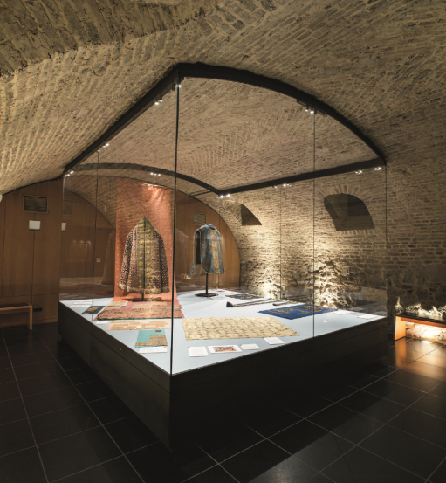
Fig. 1: Zumtobel developed an LED lighting solution for the Aachen Cathedral Treasury that delivers effective and gentle accent lighting for the precious exhibits.
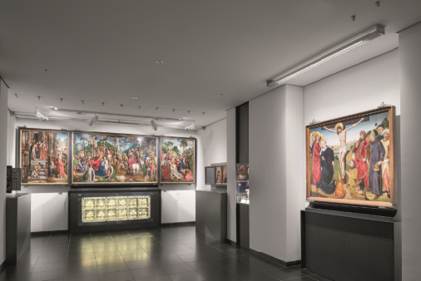
Fig. 2: The lighting meets the highest conservation requirements for the exhibits.
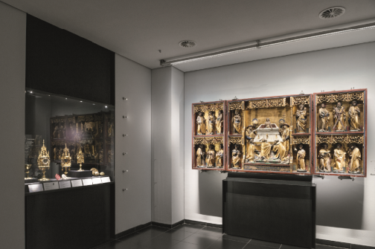
Fig. 3: The basic ambient lighting has been kept to a minimum to protect the historical artworks.
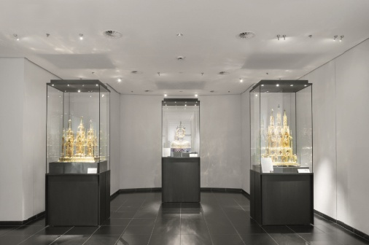
Fig. 4: Presence detectors ensure that exhibits are exposed to artificial light for as little time as possible.

Press contact:
Zumtobel Lighting GmbH
Sophie Moser
PR Manager
Schweizer Strasse 30
A-6851 Dornbirn

Tel.: +43-5572-390-26527
Mobile; +43-664-80892-3074
e-mail: sophie.moser@zumtobelgroup.com
www.zumtobel.com

Sales contact:
Zumtobel Lighting Ltd.  Chiltern Park  Chiltern Hill, Chalfont St Peter  Buckinghamshire SL9 9FG  United Kingdom  Tel: +44 1753 482 650  Fax: +44 1753 480 350  uksales@zumtobel.com  www.zumtobel.co.uk | Zumtobel Lighting Inc.  3300 Route 9  Highland , NY 12528  United States  Tel: +1 845 691-6262  Fax: +1 845 691-6289  zli.us@zumtobelgroup.com  www.zumtobel.us

For further contact details in further sales regions please visit: http://www.zumtobel.com/com-en/contact.html

About Zumtobel
Zumtobel, a leading international supplier of integral lighting solutions, enables people to experience the interplay of light and architecture. As a leader in innovation, Zumtobel provides a comprehensive range of high-quality luminaires and lighting management systems for professional interior lighting in the areas of offices, education, presentation & retail, hotel & wellness, health, art & culture as well as industry. Zumtobel is a brand of Zumtobel AG with its head office in Dornbirn, Vorarlberg (Austria).
Zumtobel. The Light.

