Press Information

the editions – Zumtobel’s First Capsule Collection
Zumtobel presents their first capsule collection consisting of five exclusive luminaires, which were originally developed and custom-made for special client projects and are now available to architects and light planners for creative and high-quality lighting solutions for the first time.
Dornbirn, 5th of December 2016 – The limited mini-collection titled the editions – Capsule collection #01 stands for the forward-thinking and innovative mindset of the Zumtobel brand and is meant to support projects that meet special requirements and challenges. The luminaires speak for themselves with their clear design and ability to offer creative solutions and technological innovation. Each product has its unique story of creation and was developed in collaboration with well-known architects and designers that have all made history in their own way with Zumtobel.
the editions – Capsule Collection #01 include five special luminaires:
TIGNUM: For customized workspace ambience
Grazer designers Benjamin and Markus Pernthaler developed an ergonomic lighting solution for the desk. The elegant and exceptionally flexible table light permits individual and targeted working zone illumination for various visual tasks. TIGNUM is also ideally suited when working on screens and with tablets.

DIAMO: Bringing sophistication to any given surface
The compact downlight is the perfect solution for a wide range of indoor applications. Thanks to concealed fixtures, hand-made reflectors and high-quality LED technology, DIAMO is more than perfect for accent lighting, boasts excellent light quality and is a real highlight when it comes to wanting maximum design freedom in the staging of architectural features.

CAMO: An infinite resource of light
With its variety of designs and different versions, this downlight is suitable for a wide range of applications and operational areas. The CAMO product range is characterized by a clear, concise design vocabulary and creates outstanding, holistic lighting moods.

ICE CUBE: Breaking office boundaries
A freestanding luminaire that can simultaneously illuminate two workstations. The transparent cube-formed lighting head was designed to almost appear afloat, while enabling the perfect balance of direct and indirect lighting. ICE CUBE not only offers efficient lighting for the work area, but also creates a pleasant lighting mood in the room.
CIELUMA: The acoustical ceiling of light
A special textile light system with a sound-reducing effect, putting the well-being of its user in focus. The light can be flexibly adjusted in color and intensity. Thus, CIELUMA creates a unique lighting mood. The light ceiling is versatile, easy to assemble and maintain, and is also compatible with various light elements.

Each of the five special luminaires has a unique history: more information, such as interviews with product designers, technical data and sources of reference for the editions - Capsule Collection # 01 can be found on the brand new website editions.zumtobel.com
the editions - Capsule Collection # 01 will be available in December 2016.

Captions:
(Photo Credits: Zumtobel)

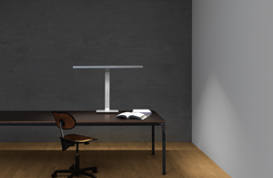
Fig. 1: TIGNUM - Grazer designers Benjamin and Markus Pernthaler developed an ergonomic lighting solution for the desk.
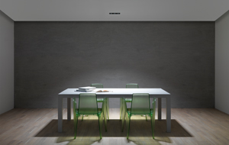
Fig. 2: DIAMO - The compact downlight is the perfect solution for a wide range of indoor applications.
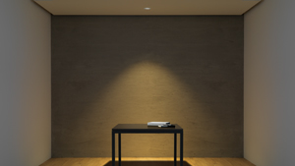
Fig. 3: CAMO - With its variety of designs and different versions, this downlight is suitable for a wide range of applications and operational areas.
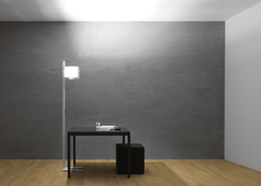
Fig. 4: ICE CUBE - A freestanding luminaire that can simultaneously illuminate two workstations.
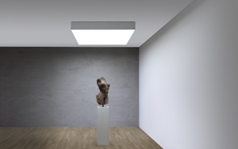
Fig. 5: CIELUMA - A freestanding luminaire that can simultaneously illuminate two workstations.
Press contact:
Zumtobel Lighting GmbH  Kiki McGowan  Head of Brand Communications  Schweizer Strasse 30  6850 Dornbirn  Phone: +43 5572 309 1303  kiki.mcgowan@zumtobelgroup.com  www.zumtobel.com | Zumtobel Lighting GmbH  Andreas Reimann  Brand PR Manager  Schweizer Strasse 30  6850 Dornbirn  Phone: +43 5572 390 26522  andreas.reimann@zumtobelgroup.com  www.zumtobel.com
Zumtobel Group  Jennifer Sewell  Marketing Communications Manager  Chiltern Park, Chiltern Hill  Chalfont St Peter, Buckinghamshire SL9 9FG  United Kingdom  Phone: +44 0 7785 232 294  jennifer.sewell@zumtobelgroup.com  www.zumtobel.com | Zumtobel Lighting Inc.  Karianna Haasch  Marketing Manager Americas  Zumtobel Lighting US  3300 Route 9W  Highland, NY 12528-2630  Phone: +1 845-691-6262 - 7611  karianna.haasch@zumtobelgroup.com  www.zumtobel.us

About Zumtobel
As a leader in innovation, Zumtobel develops sustainable lighting solutions tailored to the needs of people in their respective applications. With a comprehensive portfolio of high-quality luminaires and intelligent lighting management systems, the Austrian company provides optimum indoor and exterior products for working and living spaces - the right light for every activity at any time of day. The applications office, education, presentation and retail, hotel and wellness, health, art and culture and industry are now perfectly complemented with portfolios for living and outdoor areas. Zumtobel is a brand of Zumtobel Group AG with its head office in Dornbirn, Vorarlberg (Austria).
Zumtobel. The Light.

