Press release

Bridging the conflicting priorities of art and technology
Focusing on sustainability, the new MAK Design Lab relies on a lighting solution by Zumtobel

In the new MAK Design Lab, EOOS shows the potential of sustainable design, which aims at minimising environmental impact and maximising quality of life. An LED lighting solution by Zumtobel makes a valuable contribution towards achieving these ambitious goals.

Dornbirn, July 2014 – On the occasion of its 150th anniversary, the Museum of Applied Arts/Contemporary Art (MAK) in Vienna has reorganised its permanent study collection, the MAK Design Lab. In collaboration with the EOOS design studio and with curatorial advice from the IDRV (Institute of Design Research Vienna), MAK Director Christoph Thun-Hohenstein has implemented a concept that helps visitors experience design as a central driving force for enhancing quality of life. Design that shows that sustainability today is not only a trend, but a necessity. EOOS' design for the new MAK Design Lab has proved once again that combining aesthetic appeal and environmental compatibility not necessarily requires bargaining to the least common factor. It is against this background that the lighting solution must be seen: a continuation of the long years of cooperation between EOOS and Zumtobel.

The design approach of EOOS is based on a clear commitment: to reduce the carbon footprint as much as possible. This principle is also reflected by the decision in favour of modular solid wood pedestals, the re-use of exhibition cabinets, and energy-efficient LED luminaires. Using carbon-binding wood as the predominant material has not only a positive impact on the carbon footprint, but also creates a warm ambience that invites visitors to stay and make discoveries for themselves. The lighting solution enhances this basic atmosphere, allowing visitors authentic insights into the multi-faceted universe of applied arts. In a floor space of 2000 square metres, some 300 DISCUS evolution LED spotlights – instead of 100 halogen spotlights with poor efficiency – ensure individual presentation of approximately 2000 exhibits. Despite the threefold number of luminaires, energy consumption has been reduced by 32 per cent. Some of the spotlights are dimmable directly at the luminaire, 40 spotlights can be controlled via a DALI interface; both options have a positive impact on energy consumption and ensure sophisticated illumination of the various themed areas of the exhibition.

Not only the style of the MAK Design Lab sets new standards for environmentally compatible design; the content of the exhibition, too, aims at bringing about a new appreciation for craftsmanship and the long service life of products – hence, in the themed areas, visitors may embark on a journey through the past and future of design.
Thanks to its unmistakable look, which is characterised by the radial fins of its passive heat sink, the DISCUS spotlight seems to fit into the overall picture like an exhibit. Inspired by an ancient symbol of the sun, EOOS used all the potential of state-of-the-art LED technology for the design of the latest generation of DISCUS, implementing an even flatter design that minimises the carbon footprint. The replaceable optic extends the product's service life by making it flexibly adaptable to cope with new lighting tasks. Thanks to high-precision accent lighting, an excellent colour rendering index of Ra 92 and twice the luminous flux of its predecessors, the efficiency and effectiveness of the DISCUS evolution range is enhanced even further.

By combining state-of-the-art technology and intelligent design, EOOS and Zumtobel also managed to develop the innovative ONLITE CROSSIGN escape sign luminaire. With a power input of no more than three watts and a light output ratio of over 100 lumens per watt, the highly efficient luminaire is more than qualified to provide emergency lighting in the museum. The emergency lighting system is monitored and supplied with power by the compact ONLITE CENTRAL CPS central battery system that is based on a modular system and allows to provide a tailor-made solution, so that the relationship between functions and costs can be optimised in a consistent manner.

About the MAK
The MAK has always tried to bridge the conflicting priorities of traditions and the present. Founded in the 19th century as “Imperial-Royal Austrian Museum for Art and Industry” by Emperor Francis Joseph, it is today a museum showing art and the everyday world. In its various rooms, the museum situated on the Ringstrasse focuses on the future by confronting issues relevant to society with perspectives and approaches of contemporary art, applied arts, design and architecture, acting as a driving force that promotes a positive transformation of society, above all in social, environmental and cultural terms.

The “Hollein” exhibition will be on display at the MAK until 5 October 2014. Being Austria's only winner of the Pritzker prize and a designer in the most comprehensive sense of the word, Hans Hollein conveyed a new dimension to the term “architecture”. Plunging into his universe, the exhibition attempts a radical repositioning of his oeuvre based on material from Hans Hollein's archive, part of which has never been on public display before.

Captions:
(Photo credits: MAK DESIGN LAB, 2014 © Bruno Klomfar / Zumtobel)
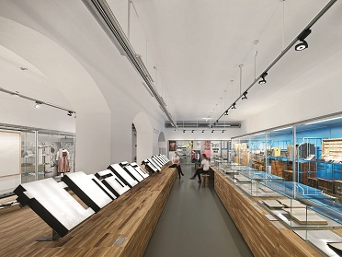
Fig. 1: The new concept of the MAK Design Lab shows design as a central driving force for enhancing quality of life
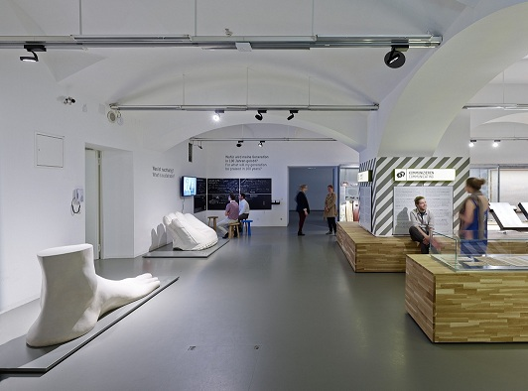
Fig. 2: On a floor space of 2000 square metres, some 300 DISCUS evolution LED spotlights – instead of 100 halogen spotlights with low efficiency – ensure individual presentation of approximately 2000 exhibits.
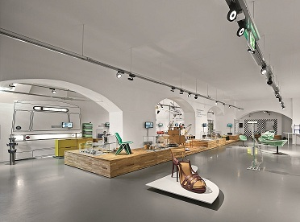
Fig. 3: Thanks to its unmistakable look, which is characterised by the radial fins of its passive heat sink, the DISCUS spotlight seems to fit into the overall picture like an exhibit. The escape sign luminaires, too, are the result from cooperation between EOOS and Zumtobel.
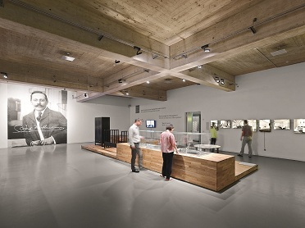
Fig. 4: Using carbon-binding wood as material has not only a positive impact on the carbon footprint, but also creates a warm ambience that invites visitors to stay and make discoveries for themselves.

Press contact:
Zumtobel Lighting GmbH
Sophie Moser
PR Manager
Schweizer Strasse 30
A-6851 Dornbirn

Tel.: +43-5572-390-26527
Mobile: +43-664-80892-3074
E-mail: sophie.moser@zumtobel.com

www.zumtobel.com

About Zumtobel
Zumtobel, a leading international supplier of integral lighting solutions, enables people to experience the interplay of light and architecture. As a leader in innovation, Zumtobel provides a comprehensive range of high-quality luminaires and lighting management systems for professional interior lighting in the areas of offices, education, presentation & retail, hotel & wellness, health, art & culture as well as industry. Zumtobel is a brand of Zumtobel AG with its head office in Dornbirn, Vorarlberg (Austria).
Zumtobel. The Light.

