Press release
Zumtobel partners with Amsterdam Light Festival
Zumtobel supports major lighting projects of the 3rd Amsterdam Light Festival
Starting on 27. November 2014, the Amsterdam Light Festival will be illuminating the Dutch capital this winter. The boat tour Water Colors opens with artworks by Jacques Rival, Angus Muir, Alaa Minawi and other artists. In addition, from 11. December, a collection of 15 artworks will light up the walking tour “Illuminade” in the Plantage district of the city. A total of 40 installations will transform Amsterdam into a truly spectacular winter festival. Zumtobel is supporting the Amsterdam Light Festival as main sponsor, whilst also helping to realize two major art projects at the event.
Amsterdam, 28. November 2014 – The jury is made up of a panel of art experts and enthusiasts who judged a varied selection of works. Most pieces have been specially created for the Amsterdam Light Festival and have never previously been exhibited. The city will be awash with light sculptures, projections and installations by contemporary local and international artists. The boat route, “Water Colors”, will take visitors past artworks along the Amstel and the city’s famous network of canals. The walking route, “Illuminade”, winds through the city center. Light will play a central role throughoutthe city during the festival, as museums and institutions organize light-related activities and treat visitors to some of the latest innovations in the world of light art.
The theme for the festival, ‘A Bright City’, challenges artists to create a tribute to modern Amsterdam. The resulting artworks will present a unique take on contemporary urban life in the Dutch capital. The Austrian lighting solutions partner Zumtobel is acting as a key partner for the realization of central artworks at the Amsterdam Light Festival by providing advice and lighting solutions developed specifically for the event. As well as sponsoring the whole festival, Zumtobel is also helping to realize two major installations: INTREPID, The Paper Boat by Katja Galyuk/City+Light and Re(bi)cycle Dome by Vasili Popov.
“By partnering with the Amsterdam Light Festival, we are fostering our strong engagement with light and art,” says Stefan von Terzi, Marketing Director at Zumtobel. “We are looking forward to taking part in one of the largest light festivals in Europe, supporting artists and designers both with our lighting solutions and our experience.”
Zumtobel to open LightLab in Amsterdam
On 16. January 2015, Zumtobel will officially open a brand new creative design center in the city of Amsterdam. The opening will be accompanied by the first ever exhibition of their renowned Masterpieces Collection, containing unique light sculptures by Zahad Hadid, Olafur Eliasson and Daniel Libeskind. The Masterpieces Collection will be then on show to the public at the well-known Amsterdam Center for Architecture (ARCAM) until the middle of March 2015.
About Amsterdam Light Festival
Amsterdam Light Festival is the winter light festival for everyone, regardless of age. The historic city center of Amsterdam is the atmospheric backdrop of the light and water festival lasting more than 50 winter days. The festival shows light sculptures and projections of contemporary (international) artists in public space. Amsterdam Light Festival brings light during the darkest period of the year and illuminates the audience with colorful artworks.
http://www.amsterdamlightfestival.com/

Captions:
(Photo Credits: Janus van den Eijnden)
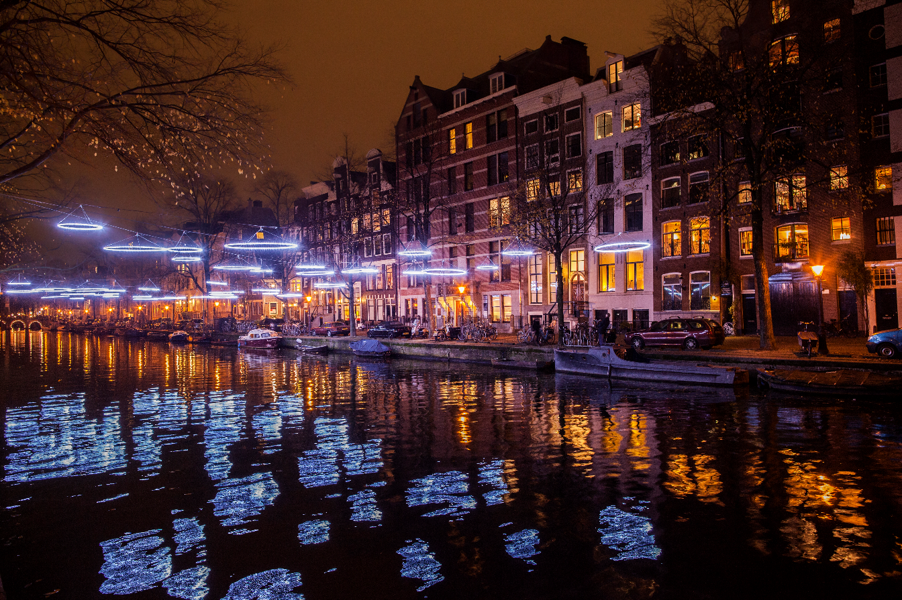
Fig. 1: The third edition of the Amsterdam Light Festival will be illuminating the Dutch capital this winter.
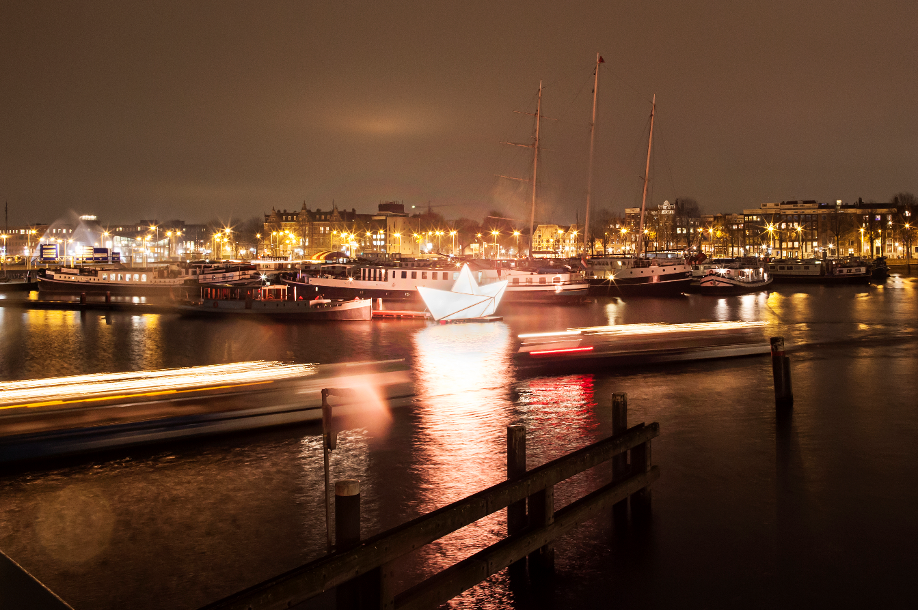
Fig. 2: Zumtobel is supporting the Amsterdam Light Festival as main sponsor, whilst also helping to realize two major art projects at the event.
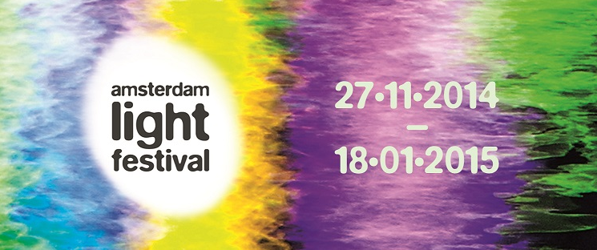

Fig. 3: Header Amsterdam Light Festival.
Press contact Amsterdam Light Festival:
For more information, interview requests or royalty-free images please contact:

Coebergh Communicatie & PR
Anne van der Wel
Leidsegracht 38-40
NL-1016 CM Amsterdam

T +31 (0)20 470 87 87
E anne@coebergh.nl

Press contact Zumtobel:
Zumtobel Lighting GmbH  Sophie Moser  PR Manager  Schweizer Strasse 30  A-6850 Dornbirn  Tel +43-5572-390-26527  Mobil +43-664-80892-3074  E-Mail press@zumtobel.com  www.zumtobel.com | N.V. Zumtobel Lighting S.A.  Jacques Brouhier  Marketing Manager Benelux  Rijksweg 47  IndustriezonePuurs 442  2870 Puurs  Phone: +32/(0)3/860.93.93  jacques.brouhier@zumtobelgroup.com  www.zumtobel.be  www.zumtobel.nl  www.zumtobel.lu
Salescontact:
N.V. Zumtobel Lighting S.A.
Rijksweg 47 – Industriezone Puurs Nr. 442
B-2870 Puurs

Tél.: +32 3 860 93 93
Fax : +32 3 886 25 00
info@zumtobel.be
info@zumtobel.lu

www.zumtobel.be
www.zumtobel.nl
www.zumtobel.lu

For further contact details in further sales regions please visit: http://www.zumtobel.com/com-en/contact.html

About Zumtobel
Zumtobel, a leading international supplier of integral lighting solutions, enables people to experience the interplay of light and architecture. As a leader in innovation, Zumtobel provides a comprehensive range of high-quality luminaires and lighting management systems for professional interior lighting in the areas of offices, education, presentation & retail, hotel & wellness, health, art & culture as well as industry. Zumtobel is a brand of Zumtobel AG with its head office in Dornbirn, Vorarlberg (Austria).
Zumtobel. The Light.

